Environment Preparation

We first upload the R libraries that are necessary for the complete analysis

rm(list=ls()) # free up memory for the download of the data sets
setwd("~/Cursos/Data Science/08 Practical Machine Learning/Projeto")
library(knitr)
library(caret)
library(rpart)
library(rpart.plot)
library(rattle)
library(randomForest)
library(corrplot)
set.seed(12345)

Data Loading and Cleaning

The next step is loading the dataset from the URL provided above. The training dataset is then partinioned in 2 to create a Training set (70% of the data) for the modeling process and a Test set (with the remaining 30%) for the validations. The testing dataset is not changed and will only be used for the quiz results generation.

# set the URL for the download
UrlTrain <- "http://d396qusza40orc.cloudfront.net/predmachlearn/pml-training.csv"
UrlTest <- "http://d396qusza40orc.cloudfront.net/predmachlearn/pml-testing.csv"

# download the datasets
training <- read.csv(url(UrlTrain))
testing <- read.csv(url(UrlTest))

# create a partition with the training dataset
inTrain <- createDataPartition(training$classe, p=0.7, list=FALSE)
TrainSet <- training[inTrain, ]
TestSet <- training[-inTrain, ]
dim(TrainSet)
## [1] 13737 160
dim(TestSet)
## [1] 5885 160

Both created datasets have 160 variables. Those variables have plenty of NA, that can be removed with the cleaning procedures below. The Near Zero variance (NZV) variables are also removed and the ID variables as well.
# remove variables with Nearly Zero Variance
NZV <- nearZeroVar(TrainSet)
TrainSet <- TrainSet[, -NZV]
TestSet <- TestSet[, -NZV]
dim(TrainSet)
## [1] 13737 106
dim(TestSet)
## [1] 5885 106
# remove variables that are mostly NA
AllNA <- sapply(TrainSet, function(x) mean(is.na(x))) > 0.95
TrainSet <- TrainSet[, AllNA==FALSE]
TestSet <- TestSet[, AllNA==FALSE]
dim(TrainSet)
## [1] 13737 59
dim(TestSet)
## [1] 5885 59
# remove identification only variables (columns 1 to 5)
TrainSet <- TrainSet[, -(1:5)]
TestSet <- TestSet[, -(1:5)]
dim(TrainSet)
## [1] 13737 54
dim(TestSet)
## [1] 5885 54

With the cleaning process above, the number of variables for the analysis has been reduced to 54 only.

Correlation Analysis

A correlation among variables is analysed before proceeding to the modeling procedures.
corMatrix <- cor(TrainSet[, -54])
corrplot(corMatrix, order = "FPC", method = "color", type = "lower",
tl.cex = 0.8, tl.col = rgb(0, 0, 0))

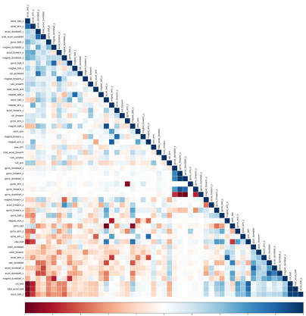

The highly correlated variables are shown in dark colors in the graph above. To make an evem more compact analysis, a PCA (Principal Components Analysis) could be performed as pre-processing step to the datasets. Nevertheless, as the correlations are quite few, this step will not be applied for this assignment.

Prediction Model Building

Three methods will be applied to model the regressions (in the Train dataset) and the best one (with higher accuracy when applied to the Test dataset) will be used for the quiz predictions. The methods are: Random Forests, Decision Tree and Generalized Boosted Model, as described below.
A Confusion Matrix is plotted at the end of each analysis to better visualize the accuracy of the models

a) Method: Random Forest

# model fit
set.seed(12345)
controlRF <- trainControl(method="cv", number=3, verboseIter=FALSE)
modFitRandForest <- train(classe ~ ., data=TrainSet, method="rf",
trControl=controlRF)
modFitRandForest$finalModel

##
## Call:
## randomForest(x = x, y = y, mtry = param$mtry)
## Type of random forest: classification
## Number of trees: 500
## No. of variables tried at each split: 27
##
## OOB estimate of error rate: 0.2%
## Confusion matrix:
## A B C D E class.error
## A 3904 1 0 0 1 0.0005120328
## B 7 2650 1 0 0 0.0030097818
## C 0 5 2391 0 0 0.0020868114
## D 0 0 7 2244 1 0.0035523979
## E 0 0 0 5 2520 0.0019801980

# prediction on Test dataset
predictRandForest <- predict(modFitRandForest, newdata=TestSet)
confMatRandForest <- confusionMatrix(predictRandForest, TestSet$classe)
confMatRandForest

## Confusion Matrix and Statistics
##
## Reference
## Prediction A B C D E
## A 1674 5 0 0 0
## B 0 1133 3 0 0
## C 0 1 1023 9 0
## D 0 0 0 955 4
## E 0 0 0 0 1078
##
## Overall Statistics
##
## Accuracy : 0.9963
## 95% CI : (0.9943, 0.9977)
## No Information Rate : 0.2845
## P-Value [Acc > NIR] : < 2.2e-16
##
## Kappa : 0.9953
## Mcnemar's Test P-Value : NA
##
## Statistics by Class:
##
## Class: A Class: B Class: C Class: D Class: E
## Sensitivity 1.0000 0.9947 0.9971 0.9907 0.9963
## Specificity 0.9988 0.9994 0.9979 0.9992 1.0000
## Pos Pred Value 0.9970 0.9974 0.9903 0.9958 1.0000
## Neg Pred Value 1.0000 0.9987 0.9994 0.9982 0.9992
## Prevalence 0.2845 0.1935 0.1743 0.1638 0.1839
## Detection Rate 0.2845 0.1925 0.1738 0.1623 0.1832
## Detection Prevalence 0.2853 0.1930 0.1755 0.1630 0.1832
## Balanced Accuracy 0.9994 0.9971 0.9975 0.9949 0.9982

# plot matrix results
plot(confMatRandForest$table, col = confMatRandForest$byClass,
main = paste("Random Forest - Accuracy =",
round(confMatRandForest$overall['Accuracy'], 4)))

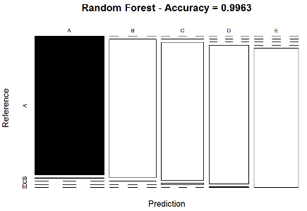

b) Method: Decision Trees

# model fit
set.seed(12345)
modFitDecTree <- rpart(classe ~ ., data=TrainSet, method="class")
fancyRpartPlot(modFitDecTree)

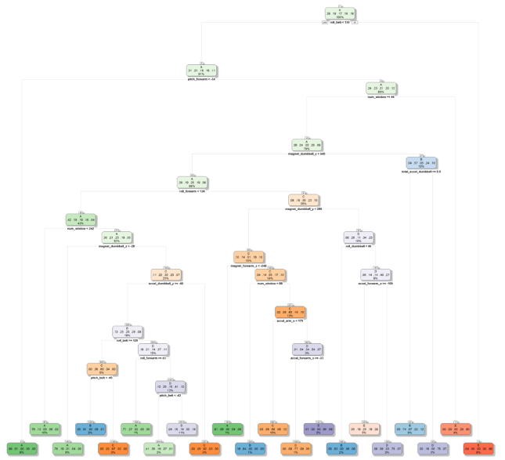

# prediction on Test dataset
predictDecTree <- predict(modFitDecTree, newdata=TestSet, type="class")
confMatDecTree <- confusionMatrix(predictDecTree, TestSet$classe)
confMatDecTree

## Confusion Matrix and Statistics
##
## Reference
## Prediction A B C D E
## A 1530 269 51 79 16
## B 35 575 31 25 68
## C 17 73 743 68 84
## D 39 146 130 702 128
## E 53 76 71 90 786
##
## Overall Statistics
##
## Accuracy : 0.7368
## 95% CI : (0.7253, 0.748)
## No Information Rate : 0.2845
## P-Value [Acc > NIR] : < 2.2e-16
##
## Kappa : 0.6656
## Mcnemar's Test P-Value : < 2.2e-16
##
## Statistics by Class:
##
## Class: A Class: B Class: C Class: D Class: E
## Sensitivity 0.9140 0.50483 0.7242 0.7282 0.7264
## Specificity 0.9014 0.96650 0.9502 0.9100 0.9396
## Pos Pred Value 0.7866 0.78338 0.7543 0.6131 0.7305
## Neg Pred Value 0.9635 0.89051 0.9422 0.9447 0.9384
## Prevalence 0.2845 0.19354 0.1743 0.1638 0.1839
## Detection Rate 0.2600 0.09771 0.1263 0.1193 0.1336
## Detection Prevalence 0.3305 0.12472 0.1674 0.1946 0.1828
## Balanced Accuracy 0.9077 0.73566 0.8372 0.8191 0.8330

# plot matrix results
plot(confMatDecTree$table, col = confMatDecTree$byClass,
main = paste("Decision Tree - Accuracy =",
round(confMatDecTree$overall['Accuracy'], 4)))

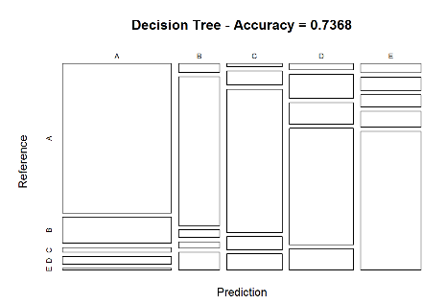

c) Method: Generalized Boosted Model

# model fit
set.seed(12345)
controlGBM <- trainControl(method = "repeatedcv", number = 5, repeats = 1)
modFitGBM <- train(classe ~ ., data=TrainSet, method = "gbm",
trControl = controlGBM, verbose = FALSE)
modFitGBM$finalModel

## A gradient boosted model with multinomial loss function.
## 150 iterations were performed.
## There were 53 predictors of which 41 had non-zero influence.

# prediction on Test dataset
predictGBM <- predict(modFitGBM, newdata=TestSet)
confMatGBM <- confusionMatrix(predictGBM, TestSet$classe)
confMatGBM

## Confusion Matrix and Statistics
##
## Reference
## Prediction A B C D E
## A 1669 13 0 2 0
## B 4 1113 23 5 3
## C 0 13 998 16 2
## D 1 0 5 941 8
## E 0 0 0 0 1069
##
## Overall Statistics
##
## Accuracy : 0.9839
## 95% CI : (0.9803, 0.9869)
## No Information Rate : 0.2845
## P-Value [Acc > NIR] : < 2.2e-16
##
## Kappa : 0.9796
## Mcnemar's Test P-Value : NA
##
## Statistics by Class:
##
## Class: A Class: B Class: C Class: D Class: E
## Sensitivity 0.9970 0.9772 0.9727 0.9761 0.9880
## Specificity 0.9964 0.9926 0.9936 0.9972 1.0000
## Pos Pred Value 0.9911 0.9695 0.9699 0.9853 1.0000
## Neg Pred Value 0.9988 0.9945 0.9942 0.9953 0.9973
## Prevalence 0.2845 0.1935 0.1743 0.1638 0.1839
## Detection Rate 0.2836 0.1891 0.1696 0.1599 0.1816
## Detection Prevalence 0.2862 0.1951 0.1749 0.1623 0.1816
## Balanced Accuracy 0.9967 0.9849 0.9832 0.9866 0.9940

# plot matrix results
plot(confMatGBM$table, col = confMatGBM$byClass,
main = paste("GBM - Accuracy =", round(confMatGBM$overall['Accuracy'], 4)))

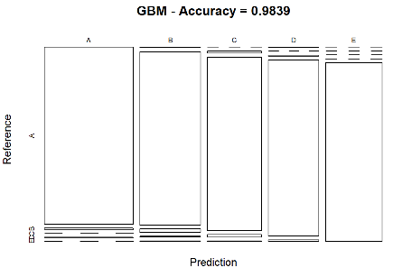

V. Applying the Selected Model to the Test Data

The accuracy of the 3 regression modeling methods above are:

Random Forest : 0.9963
Decision Tree : 0.7368
GBM : 0.9839

In that case, the Random Forest model will be applied to predict the 20 quiz results (testing dataset) as shown below.

predictTEST <- predict(modFitRandForest, newdata=testing)
predictTEST

## [1] B A B A A E D B A A B C B A E E A B B B
## Levels: A B C D E

